# **SQL RIGHT JOIN**

**SQL RIGHT JOIN:**

1. The RIGHT JOIN keyword returns all records from the right table (table2), and the matching records from the left table (table1). The result is 0 records from the left side, if there is no match.
2. The syntax:

|  |
| --- |
| SELECT column_name(s)  FROM table1  RIGHT JOIN table2  ON table1.column_name = table2.column_name; |

1. In some databases RIGHT JOIN is called RIGHT OUTER JOIN.

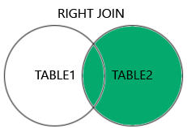

**SQL RIGHT JOIN Example:**

1. The following SQL statement will return all employees, and any orders they might have placed:  
   Example:

|  |
| --- |
| SELECT Orders.OrderID, Employees.LastName, Employees.FirstName  FROM Orders  RIGHT JOIN Employees ON Orders.EmployeeID = Employees.EmployeeID  ORDER BY Orders.OrderID; |

|  |  |  |
| --- | --- | --- |
| **OrderID** | **LastName** | **FirstName** |
|  | West | Adam |
| 10248 | Buchanan | Steven |
| 10249 | Suyama | Michael |
| 10250 | Peacock | Margaret |
| 10251 | Leverling | Janet |
| 10252 | Peacock | Margaret |